An Interview With:
December 17, 2014
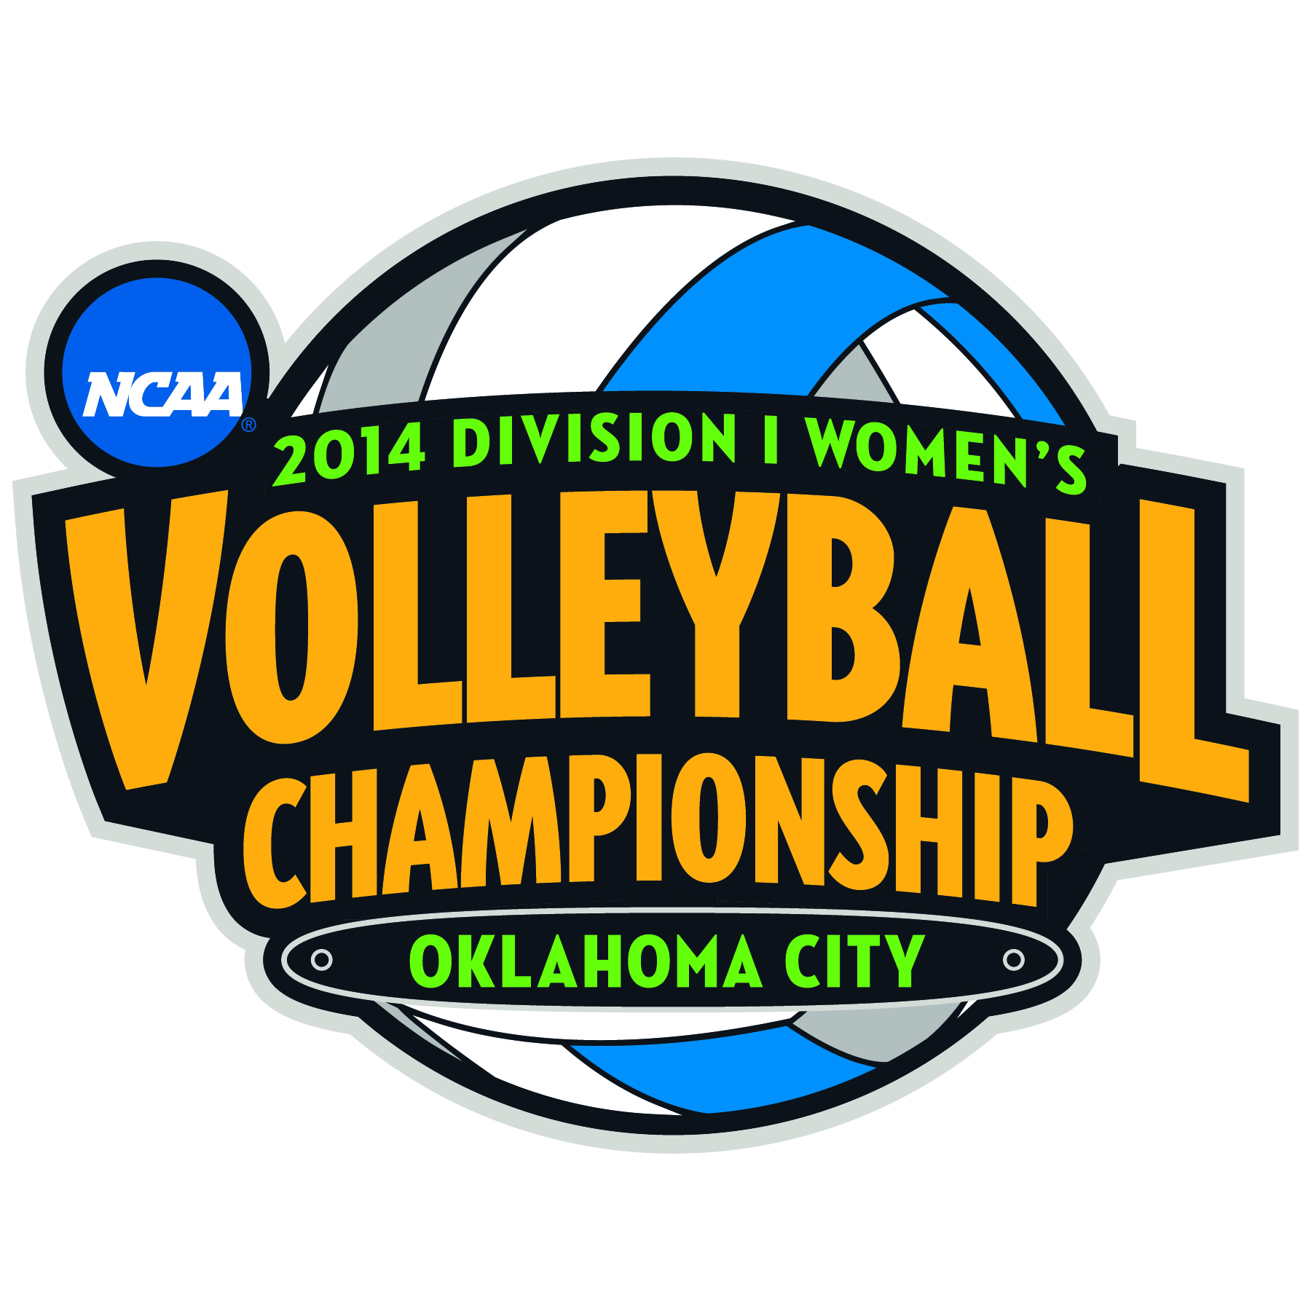

BYU

COACH SHAWN OLMSTEAD
ALEXA GRAY
AMY BOSWELL
JENNIFER HAMSON

COACH OLMSTEAD: First and foremost I want to thank everybody here in Oklahoma City, all the employees of this outstanding stadium, thanks for being here today, yesterday, the day before, last week, month, whatever is needed to prepare for this outstanding event.
Hats off as well to Penn State, Stanford, Texas and all of their players, their staff that have been kind of working away at this thing for a long time. Congrats to them on their efforts in being here. And we're excited to be here.
This is an outstanding opportunity for our kids. I'm blessed to be a part of a great group, and we're just having fun. We're going to enjoy it and do what we've been doing lately and kind of just play and be ourselves and get after it.

Q. Coach, everybody seems to be calling you guys an underdog. Do you guys embrace that or does it bother you? Do you think you're better than that? What are your thoughts?
COACH OLMSTEAD: Yeah, I mean, honestly I haven't thought too much about it. These kids haven't worried too much about that either.
They've really bought into just getting better every single day at practice. We've finished every day at practice and we look back on it and I can tell in these kids that they just feel like they've gotten better that day.
And it's happened all year. I'm bummed that whether we win or whatever we do this weekend, I'm bummed it's over because these kids just keep getting better and better and I want to see them continue to grow.

Q. Jennifer, did you miss volleyball last year?
JENNIFER HAMSON: Just a little. But I just try to enjoy what I'm doing at the moment. Just kind of focus on what I do.

Q. Coach, did you miss Jennifer last year?
COACH OLMSTEAD: Just a little. No, of course we missed Jennifer, but she was so great about that entire process. And even more importantly is I thought the girls' response, and a few of them I can't see who is here, so both of these girls were a part of that group last year, and their response.
And even more impressive was a couple of the seniors that when you go into a meeting and tell them Jen's not going to play her senior year, you could have a lot of kids react the wrong way.
And there was nothing but positive stuff. They knew Jen was making a decision she had put a lot of thought into. And she was great about it. And Jen was outstanding and supportive. We were supportive both ways, but it wouldn't have been possible without just a great group of kids.
And I think last year, you know, no doubt last year those kids might have played with a chip on their shoulder because everyone told them Jen's not coming back, but kids like Alexa and Amy and others just maybe had something to prove last year without Jen being around.

Q. Jennifer, is it safe to say right now that you don't miss basketball?
JENNIFER HAMSON: Yes.

Q. Shawn, a couple of questions. One, what goes into being the nation's top blocking team, and secondly, more importantly, is there a story behind the mustache?
COACH OLMSTEAD: Good story. There better be a story behind the mustache. No, well you've got the full beard. I can't do that.
I hope this isn't repeated in terms of I've said this before. So maybe I'm saying the same thing and you guys are looking for some scientific great coaching response. But here's the deal: 6'7", 6'4", 6'3", I mean, these kids, they're long, tall, physical, but they work at it. We put a lot of time into watching and seeing the game.
We want to see it unfold. We want to be able to see what the opponents are doing on the other side of the net. I think there's a lot of prep that's involved with my coaching staff.
I'll give them all the credit in the world to getting these kids ready for every single match. And BYU traditionally has always been an outstanding blocking team. And there may be some of that, too, just some tradition.
And just regarding the mustache, I mean, we finished playing LMU on a Tuesday. And we gave the kids a few days off. You guys went home. Some of them, Alexa went back to Canada, probably, and we had the girls come back on Friday night to practice.
So I had some days off. And BYU, you can't have a playoff beard, because -- luckily because then I might really have it scraggly. But I just didn't shave that often during that little break. My administrator is here so I gotta be careful.
Then when we came back for Selection Show, I just did a mustache and started taking selfies with the girls and celebrating. They said it's creepy but it's hilarious. We went with it. And all of a sudden we go to the first weekend and I just -- we took selfies and everyone laughed. And I'm the first to say it's horrendous for me -- for me.
But we like it, it's fun, let's do it.

Q. Alexa, how does he look with the mustache?
ALEXA GRAY: I described it earlier as filthy.
(Laughter.)
COACH OLMSTEAD: Thank you.

Q. Another question about the mustache. What sort of feedback have you been getting from any coaches, social media?
COACH OLMSTEAD: I won't throw the other coaches under the bus. There's some very, very successful and dominant coaches in the country that have called me and told me I gotta keep it. You cannot let this thing go.
I don't know if they're just trying to make me make a fool of myself or if they're being sincere. But the funny part is on Sunday after we beat Arizona, I'm in church, I get a text and I checked it and it was my sister. She had a screen shot.
I don't have Twitter or Facebook. That's just not my thing. I don't do it. And she had a screen shot of Facebook and said that it kind of had a name and it's getting Facebook hits. I don't know what that means.
But she said this is ridiculous. And that's just kind of -- like I said, they enjoy it and it's funny and we're just loving the entire thing.
And when it's time to get down to working hard, these kids just got after it in practice. They know how to do that.

Q. You mentioned all the hype around you. But yet your No. 1 blocker is 6'0". How does she do it?
COACH OLMSTEAD: I think she's kind of got a nose for the ball. She's very instinctive, and she's been really good at that and getting in the right direction of the hitters and also being pretty -- recognizing the game plan of the opponent. So the approach is coming this way, we've got to be here and get up and get over.
And I think she's also got really good help around her in terms of the people to the right and to the left. But Whitney's just -- because you're referring to Whitney -- she's also lightning fast right and left.
Wasn't she like a track state champion? Yeah, she was a state -- Idaho State Champion in track. Just a ton of raw potential when she got to BYU. And we redshirted her. And she just took total advantage of that, got stronger, got faster, and she's done an outstanding job there.
And she sees things. And like I said, she just does things really good technically which help her. She's not reaching all over the place. She's just straight up and over. If you watch her, it's fun to watch that kid block.

Q. Amy, you're such a talker, haven't had a chance. First of all, congratulations. I guess all three got AVCA All-American at one level or another, including you Amy. But I'd like to talk about a teammate who isn't at the podium, and that's your setter, Alohi. Would you tell us why you think she's had so much success, particularly against Nebraska, and what she's doing that has allowed those of you who are hitting do what you do?
AMY BOSWELL: She's been great. She's one of those people who you know just works hard and who is going to put the ball in the same spot every time. We as team, we say our goals every once in a while, and she says I need my set location.
That's something I know that's she's been focusing on. It's nice as hitters to know the ball is going to be in the same spot every time and it's predictable and it allows us to go attack the ball.

Q. Jen is also a basketball player, is she not?
UNIDENTIFIED: Yeah.

Q. What difference does that make in your game and her approach?
UNIDENTIFIED: I think it helps her, because you get a lot of experience from different teams and from basketball that help over into volleyball, and I think she works hard and she uses her time wisely. I don't know, I think she's a great player and I'm excited.

Q. With all due respect, but if this were an SAT question, team, team, team, which team does not belong in this group? I know you've seen the slogan all week, Why Not Us, but you had to address that at some point --
COACH OLMSTEAD: No, I did. Sorry, I didn't let you finish your question.

Q. Address it with your team.
COACH OLMSTEAD: Absolutely. I said the last -- Jack, I think you were there -- I went in right before we left the locker room going in to play Nebraska. I said, Girls, here's what I know what is going on. And Texas is in. Penn State is in. And I told the girls -- at the time I knew Stanford was up pretty big on Florida. And I said, Here's the last matchup of the Saturday night.
It's BYU against Nebraska. And I said who does everybody thinks fits into that 4 spot? And it was a resounding -- they didn't even need to answer nor did I want them to answer. Their eyes lit up. And I said we're going to change that.
And everybody in this room, I mean, the kids were confident in that room that we had a matchup that we believed we could compete and get after it with for sure. And I said that right before we ran out there. And someone told me Stanford won.
So right before we had our last huddle, I said, All right, Texas is in, Penn State's in, Stanford's in. Who does everybody that's here other than this group -- and of course our support, I don't mention our support -- but our group who believes is going to be in. And that kind of answers that question.
Now, we're just in a position that these kids, there's some sort of confirmation of their hard work in terms of they're the ones that put out this goal. I mean, they did it on their own. They did this a long time ago in August. To be able to actually see a plan in place in life and here it is and here's what we've got to do to get there, I mean, that's pretty darn remarkable.
We took it midway through the season and we actually reevaluated and literally where we wanted to be midway through the season the girls were exactly on track. And that was, what, like mid-October, something like that. We had a team meeting. Here's where you guys said you wanted to be at midway point.
You're right there. Let's keep getting better, like I said earlier, let's just keep grinding.

Q. Coach, I wanted to ask you about site cities for the Final Four, two true neutral sites like Oklahoma City, Kansas City and Louisville. Then you have other sites that are potentially a home court advantage. From your experience in playing a regional in Omaha, what's the degree of difficulty of playing in a site that is going to be partisan?
COACH OLMSTEAD: You know, that's a good question, because I've been I guess in the last couple of Regionals we've been in, and so is your question referring more to the Final Four or to the regional? The Final Four? Sorry. I got lost in the question, in terms is it an advantage to somebody?
You know, here's what I believe. I believe it's so hard to get here. The work and the amount that these kids have to put into it, I don't have an issue with wherever the -- I put trust in them to decide what's best for volleyball and the sport and to grow the sport.
That's what I think is really important right now is to take advantage of a lot of the success that volleyball has seen and it starts with our national team down to the collegiate athletes and to continue to build on what's the best locations to build the sport. That's my opinion.
So maybe I didn't give you exactly the right answer, but last weekend, I mean, there's some teams that had home court advantage for these regional playoffs and didn't even make it. I still think it's pretty hard.
I think you've still got to have the right team and have a lot of things go your way.

Q. Shawn, you don't seem like the kind of coach who is going to give a "one game at a time" cliche-type answer. When you see the bracket come out -- I guess when the bracket comes out, do you privately say, well, if we can get by Arizona, maybe we match up well with Florida State? I guess what I'm getting at is did you ever envision you guys being here taking that path?
COACH OLMSTEAD: I believe that we had the potential to do it, no doubt. And when I looked at the bracket, I was happy. I told the girls, Hey, I really like this. Because we did. Right there in the moment, hey, we're going to focus and get ready for Seton Hall. That was our first match-up.
And then beyond that, I told the girls, I think maybe the next day when we got back in the gym -- that was a Sunday. Monday we were practicing. I said, Girls, look at this thing, this is a wonderful opportunity for us as a squad to get things running and to really start playing well.
We were. We were coming off some nice road wins in conference, to be honest. I felt we need to go on the road and do it. Maybe these kids felt a little slighted, I don't know. Again, I'm in no part of the selection.
So the kids just rolled with it and they've been grinding on the road for, I don't know, almost six weeks straight.

Q. This may be too far out of left field, but you're certainly aware of how great the men's program is at BYU. Are you guys fans of the program? And is their success and what they've done have any influence on you in a positive way?
JENNIFER HAMSON: For sure.
AMY BOSWELL: You see those guys. We're close with them, we watch them practice every once in a while, and you just see how hard they work and their potential and the success they have definitely I think has made us proud of them and want to be better.

Q. Alexa, Nebraska had Katy Ralston going for a while, and then your defense was able to just completely take her offense away. And then as they tried to switch elsewhere, we suddenly noticed, wow, look at BYU. They involved you very early and suddenly we don't see you for a while, and then all of a sudden you come out of nowhere. Is that unusual when we saw that against Florida State and Nebraska for you to have your offense so spread across so many different attackers, or were you off your game and you should have gotten more attempts during that, or is there a bigger spread?
ALEXA GRAY: Jen was obviously on fire in the Florida State game. So I just thought like just let Jen do her thing, she's on a roll. And she can really help us.
But on the next game, I just had to step up a little bit more because we all -- it was really spread out so we needed attackers from across the whole net. So I just kept playing my game and tried to be consistent.

Q. BYU has broken multiple barriers in getting here. And one of those is you're the only non-power 5 team to be here. At the lower regional level, some coaches are a little concerned about the divisiveness between this autonomy move of the power 5 and the other schools. Do you share that concern?
COACH OLMSTEAD: That's a great question. And I do my best to follow that as it unfolds, because it's a popular, very, very popular conversation and especially with the rumors of BYU being in the Big 12 country right now.
I'm not oblivious to that and just say no, that doesn't exist. But I believe -- there's things happening, and I hope that a sport like volleyball and with the wonderful opportunities it provides these young ladies that we really look long and hard at how we manage all that. Because I think there's so much money around there trying to be moved around and pushed around.
And before you know it, the money -- I guess in life money always talks, but we're allowing sometimes maybe it to do too much talking when I'm hearing of this program's getting cut or that's getting cut because the money's gotta go to football and pump up football. And it's a bummer for student-athletes like these girls, because I think that's really, really important.
And so BYU's an outstanding name in terms of national, just recognized, and that has a lot to do with the church, with the LDS church and its worldwide base and the wonderful things the church has done to kind of spread their message in terms of not -- I'm not going to get into any gospel stuff here, but in terms of what they've done through athletics to just continue to promote good things and good standards for these kids and those people that are part of the athletic program.
THE MODERATOR: Thank you.
FastScripts by ASAP Sports

